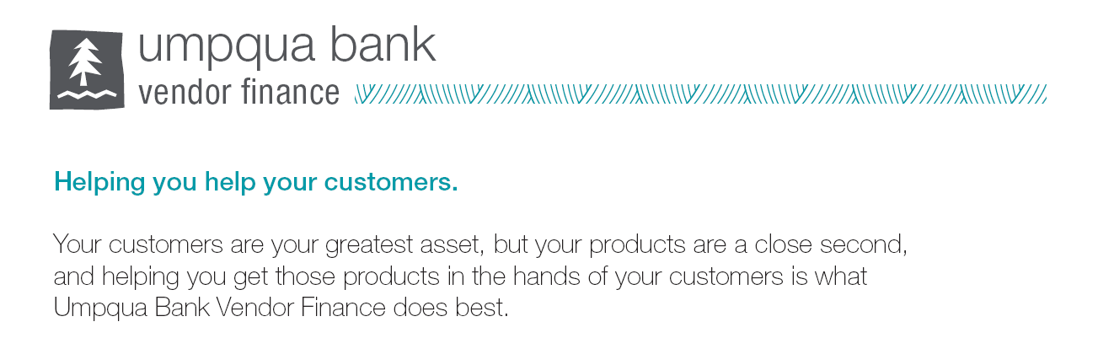
Rates good through 03/31/2023
Equipment Cost | 36 Months | 48 months | 60 Months | APR
$5,000 to $49,999 | .03134 | .02441 | .02028 | 8%
$50,000 to $149,999 | .03088 | .02395 | .01980 | 7%
$150,000+ | .03065 | .02372 | .01957 | 6.5%
On Approved Credit (A Credits)
Zero down payment Equipment Finance Agreement
These are application only rates with a minimum of two years’ time in business.
$200 admin fee for non-titled equipment and $400 admin fee for titled equipment.
Jon Ball  Regional Sales Manager  Vendor Finance  office: 503 502-5964  email: jonball@umpquabank.com | Don Crosby  Vendor Experience Representative  Vendor Finance  office: 503 327-2647  email: dcrosby@umpquabannk.com
